
INSTALLATION INSTRUCTIONS, KIT #55914
S/K SERIES LIFTS – PCB RI55664
- Read and understand supplemental instructions completely before any work is attempted. Refer to the Service/Owner Manual for additional safety precautions.
- Check contents of this kit and notify Ricon immediately of any missing parts. Claims for damages that have occurred during shipping must be made to the shipper.
TABLE OF CONTENTS PAGE
  - PARTS LIST………………………………………………………………………………………………………………………..1
  - TOOLS REQUIRED 1
  - INTRODUCTION 2
    - REMOVE FACTORY PCB 2
  - INSTALLATION OF KIT #55914……………………………………………………………………………………………….2-5
    - INSTALLATION OF PCB ASSEMBLY…………………………………………………………………………………...2-4
    - INSTALLATION OF EXTENSION HARNESS, J2………………………………………………………………………4-5
    - FINAL INSTALLATION………………………………………………………………………………………………………5
- Under no circumstances is maintenance, repair, or adjustment of the R2000 Power Seat Base to be performed without the presence of an individual capable of giving aid.
- Give immediate attention to all injuries, and administer first-aid, or seek medical attention as necessary.
- Protective eye shields and clothing should be worn during maintenance, repair, and adjustment of the R2000 Power Seat Base.
- Work in a properly ventilated area.
- Check for hidden obstructions before drilling and cutting. Avoid interference with wiring, fuel tank, fuel lines, hydraulic lines, subfloor members, etc.
- Read and understand all instructions before attempting to operate the S/K Series Lift.
- Read and understand all instructions before attempting to perform maintenance, repairs, or adjustments to the S/K Series Lift.
- Read and comply with warning labels attached to the S/K Series Lift.

- pARTS LIST
- 55664, PC BOARD ASSY. w/TWS,FOUR SENSORS
- 55913, HARNESS, JUMPER, EXTENSION

- TOOLS REQUIRED
- PHILLIPS SCREW DRIVER
- WIRE CUTTER
- WIRE STRIPPER
- WIRE CRIMPER
- 3/8” DRIVE RATCHET HANDLE
- 9/16” SOCKET, 3/8” DRIVE
- 1/2" SOCKET, 3/8” DRIVE

- INTRODUCTION
The purpose of this document is to outline the step by step procedure for the installation of Kit #55914 for PCB RI55664 and Extension Harness RI55913 (if needed) for the S/K Series Lifts. Follow all safety precautions before attempting to perform installation or maintenance of the S/K Series Lift. Remove power to vehicle and/or turn off ignition. Remove the power cable from the S/K Series Lift.

- REMOVAL OF FACTORY PCB
Note: The Pump assembly may or may not need to be removed depending on the lift configuration (Left hand or Right hand side) and location of PCB. If removal is unnecessary, skip to step 3 below.
- Remove the pump cover, making sure to unplug the warning light if installed, and set aside.
- Unbolt the pump assembly; pull and tie away from the lift for optimum working area. Removal of the hydraulic lines and/or electrical connections may be necessary.
- Important! Locate factory PCB. Remove electrical connections from PCB, making sure to make a note or mark the connections for terminals T1-T4 for ease of identification and installation later.
- Remove the factory PCB assembly from the lift.
- Remove the factory PCB from the PCB mounting plate.
- Install PCB RI55664 onto the PCB mounting plate.

- INSTALLATION OF KIT #55914
- INSTALLATION OF PCB ASSEMBLY
Note: PCB RI55664 is sent configured from the manufacturer with jumpers in the following locations; J9, J14.
      - Configure the jumpers on PCB RI55664 for the lift application. Remove jumpers as needed.
Refer to Figure 1.

If Replacing | Leave | Remove
33461 | J9, J14 | N/A
33057 | J14 | J9
55809 | J9 | J14
47388 | J9 | J14
55664 | J9 | J14
FIGURE 1: PCB RI55664 JUMPER CONFIGURATION MATRIX

      - Install the PCB assembly on the lift.
      - Install TWS sensor sets to PCB, ensuring TWS sensors sets are properly connected. Refer to Figures 2-3.

TWS Sensor Set # | Sensor Set Location
1 | J4, J5
2 | J6, J7
3 (If applicable) | J13, J14
figure 2: pcb ri55664 tws sENSOR sET LOCATIONS

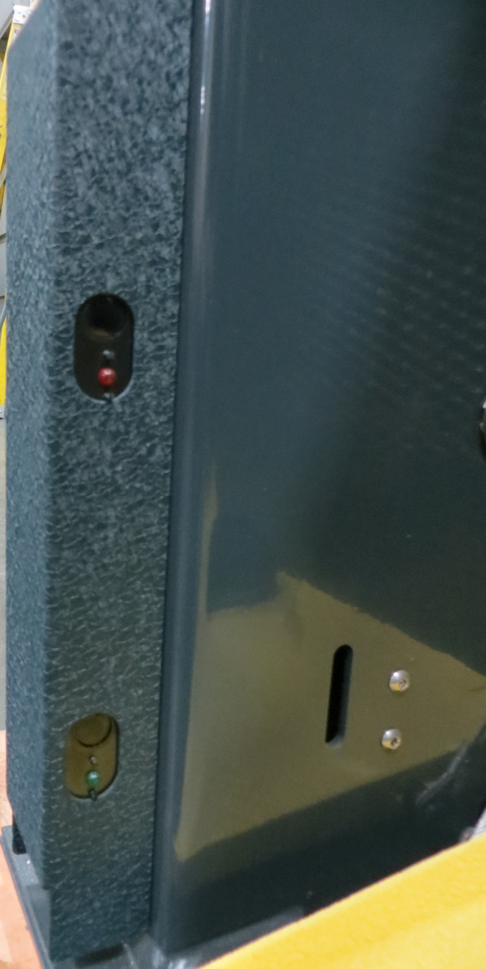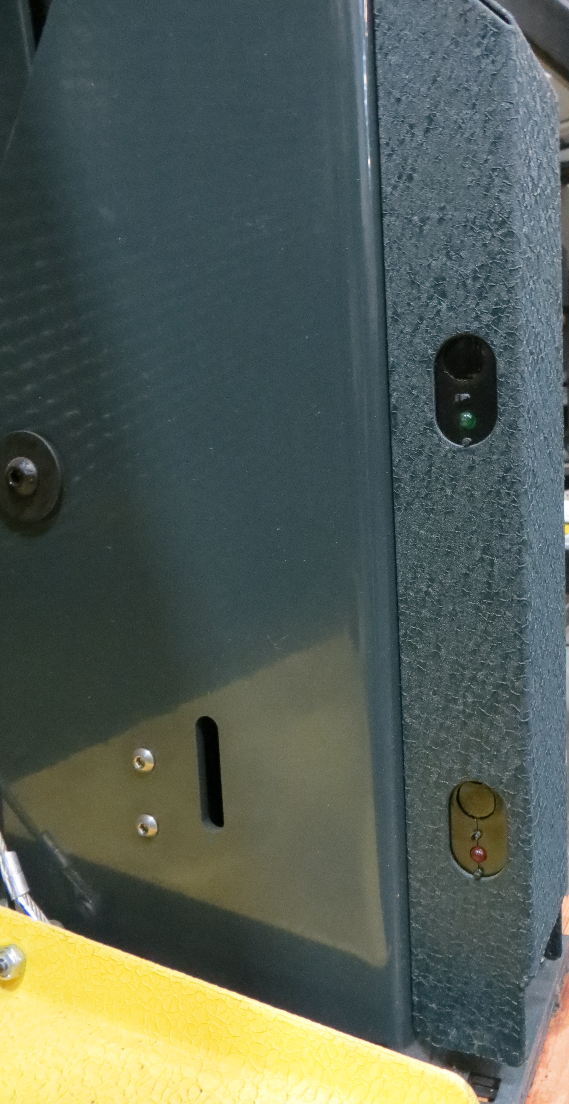
LEFT
RIGHT
SET 1
SET 2
SET 3
(If Applicable)

TX (RED)
RX (GREEN)
figure 3: tws sENSOR sET Identification

4. Install Terminal T1-T4 in the correct PCB location. Refer to Figures 4-5.

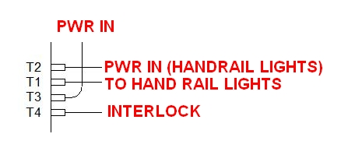
FIGURE 4: PREVIOUS TERMINAL ORIENTATION

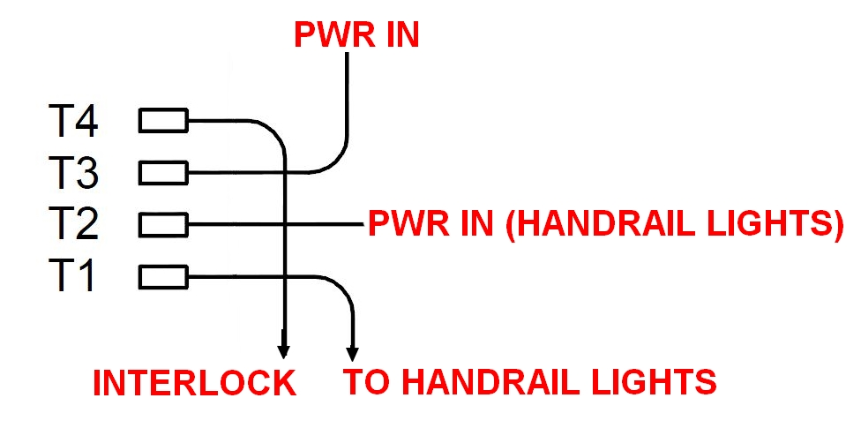
FIGURE 5: NEW TERMINAL ORIENTATION

4. Install remaining electrical connections to PCB.

- INSTALLATION OF EXTENSION HARNESS, J2
Note: Depending on the lift application, the J2 connector harness may or may not need to be extended. If upon installing PCB assembly RI55664 the harness does not reach connector J2, proceed with section B. Otherwise, continue to section C.

1. Locate harness connector that mates with J2 and cut wires at end of connector. Refer to Figures 6A-6B. Strip the wire ends as necessary.
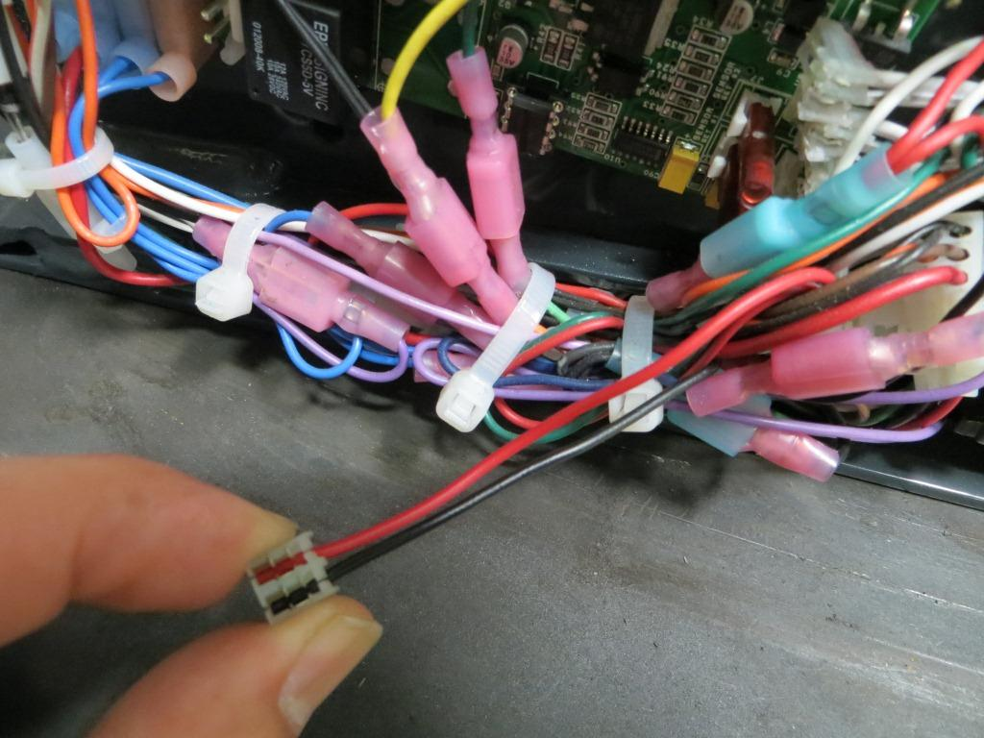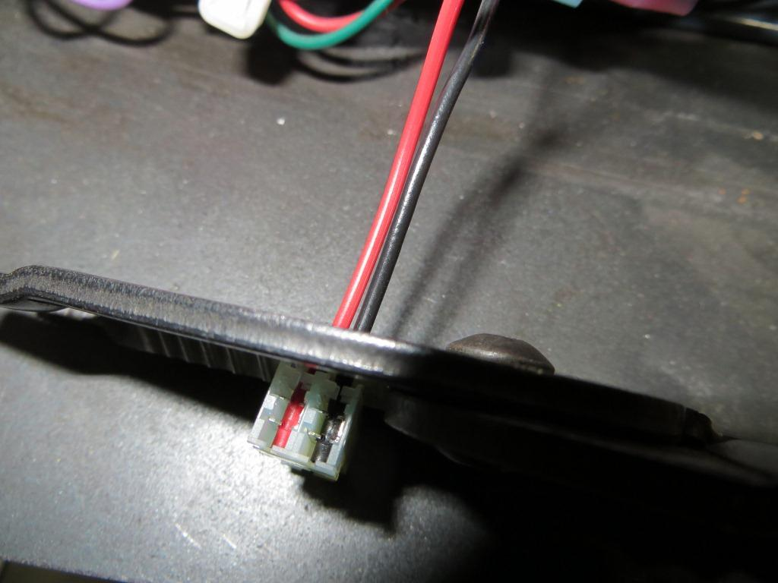
FIGURES 6A/6B: REMOVAL OF HARNESS CONNECTOR, J2

2. Splice in extension harness RI55913. Connect the extended harness to J2 on the PCB. Refer to Figures 7A-7B.
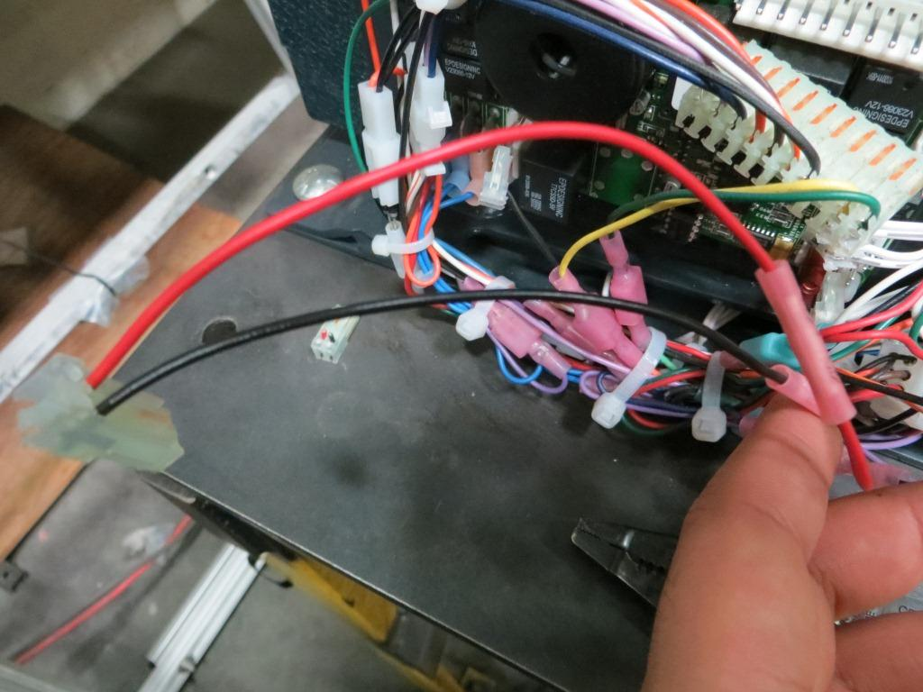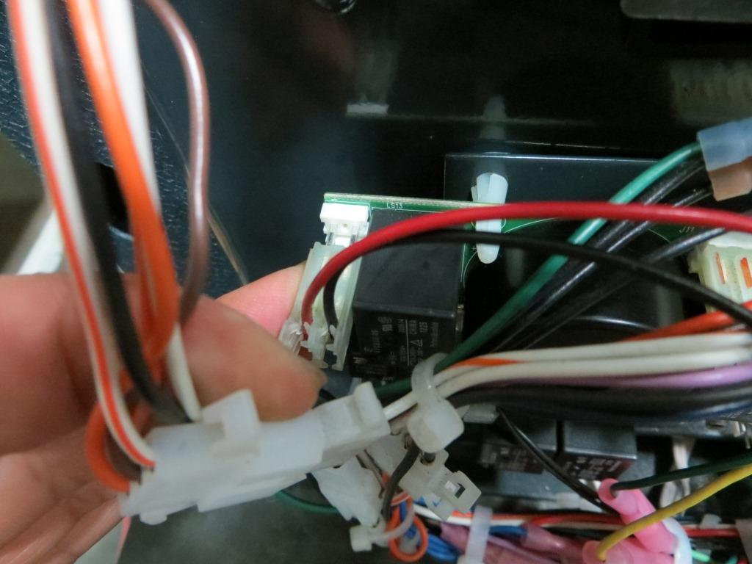
FIGURES 7A/7B: HARNESS EXTENSION INSTALLATION (REFERENCE ONLY)

C. FINAL INSTALLATION

- Re-install the pump assembly to the lift; reconnect hydraulic lines and electrical connections if applicable.

- Re-install the pump cover, making sure to plug the warning light if installed.

